Exercise 7: Igneous Rocks 90 points

Geology Lab 111 Name_________________________________________________________________
Objectives:
- Learn how to distinguish between extrusive (volcanic) and intrusive (plutonic) igneous rocks.
- Learn how to distinguish igneous rocks from other rock types.
- Understand what history is implied when particular igneous rocks are visible at the surface.
- Learn the names of the different igneous rocks and how to distinguish them from one another.
Extrusive (Volcanic) versus Intrusive (Plutonic) Igneous Rocks
Igneous rocks are rocks that have crystallized from molten state. You can easily distinguish between extrusive igneous rocks (rocks that formed from lava cooling on the surface or from lava exploding out of a volcano and freezing in little ash particles in the air) and intrusive igneous rocks (rocks that formed as magma cooled and crystallized below the Earth’s surface).

Cooling Rate
Super fast = quenching: makes glass (no crystals at all)
The rate at which magma or lava cools generally determines the size of the crystals that form as the magma or lava cools and crystallizes. Lava that flows onto the surface of the Earth (lava temperatures vary from 700-1200° C whereas the Earth’s surface is generally cooler than 40° C) loses heat rapidly. If heat loss is rapid enough, the disorganized atoms and molecules that were floating freely while in a hot, liquid state are suddenly frozen into place. The result is a solid substance that has no extensive organization of atoms, and therefore no mineral crystals (see the definition of a mineral in Exercise 5); such a substance is known as a glass. Glassy substances do not contain true minerals. The atoms and molecules in the glass are not arranged in any particular order. Their positions relative to one another are random. Volcanic glass is known as obsidian.

Fast = rapid cooling over hours or a few days: makes microscopically small crystals
If lava at the Earth’s surface is not suddenly frozen, it will still lose heat relatively quickly. For example, as lava flows across the ground, the lava that makes contact with the ground and the air is chilled rapidly, forming a glassy obsidian crust. The glassy crust prevents extremely rapid heat loss from the middle of the lava flow. Consequently, the middle of the lava flow cools over the course of days, weeks or years, depending upon the thickness of the lava flow. This more moderate rate of heat loss, although still rapid, allows the freely floating atoms and molecules in the lava to electromagnetically interact with one another as they slow down (lose heat). When some atoms and molecules do freeze into place, the electromagnetic forces between them have caused them to organize into orderly, geometric arrays to form the seeds of true mineral crystals floating around in the lava. As the lava continues to cool, these seed crystals provide a template upon which atoms continue to arrange themselves until the lava is completely frozen. However, because heat loss has occurred relatively rapidly, many tiny seed crystals form rapidly providing many sites for crystal growth. The result is that when the lava is finally solid, it consists of many small or even microscopic crystals. The resulting extrusive igneous rock may or may not have a few large, visible crystals but generally will have a uniform color and appearance because of the smallness of the majority of the crystals. If lava is blown out of a volcano into the air, the result will be a hot, fine ash that falls to the ground in steaming piles that weld together to form pyroclastic igneous rocks that generally also have a uniform color, but which may contain large stone fragments (clasts) and which also may show layering (like sedimentary rocks—something that can make their identification confusing to novices).

Slow = cooling underground=over months or years: makes sand-sized to thumb-sized crystals (or bigger)
Intrusive (or plutonic, after Pluto, Roman god of the underworld) igneous rocks form as magma cools very slowly over months or years deep below the Earth’s surface. Magma cools so slowly within the Earth for several reasons. Firstly, the temperature of the solid rock a few miles below the surface is already around 100-300 C, so magma that intrudes into such rock and remains there does not experience the cool surroundings experienced by lava at the Earth’s surface. Secondly, solid rock (whether hot or cold) acts as an insulator or blanket, preventing rapid heat loss. Heat simply does not move through solid rock as quickly as it does through metal, air, or water. So, as magma cools and crystallizes within the Earth, fewer seed crystals develop in the magma. The atoms and molecules in the magma continue to slowly move through the magma to favorable bonding sites and the result is that crystals grow to a large size that is visible to the naked eye.

Extrusive = glassy or microscopic crystals vs Intrusive = visible crystals
Extrusive igneous rocks generally have a uniform color and texture with perhaps some visible crystals, whereas intrusive igneous rocks are composed of many different crystals that are large enough to be visible, giving intrusive igneous rocks a spotted or splotchy appearance.

Distinctiveness of Igneous Rocks
Igneous rocks are distinguished from sedimentary and metamorphic rocks by their relative hardness, the general lack of any kind of layering (except for pyroclastic volcanic rocks), and by the types of minerals they contain. Geologists always consider “occurrence” when trying to identify rocks as well. Extrusive igneous rocks can be found in between the layers of sedimentary rocks. If you imagine a plain covered with layer upon layer of sand, lava flowing across that sandy plain will cool, be buried more sand and occur between layers of sand. Intrusive igneous rocks generally occur as blobs or near vertical veins or sheet-like bodies that cut across any layered rocks that may be present in the area.

Implications of Finding Igneous Rocks
- Igneous rocks are very common. The bedrock that can be seen on the hillside on the GCC campus is composed of granodiorite, an intrusive igneous rock. Explain what this must mean about the geological history here.

- If you find layers and layers of extrusive igneous rocks in a particular place, what must that mean about the geological history of that area? How could you tell by just looking at the landscape if the activity was recent (with the potential for more activity) or ancient (and volcanically dead)?

Identifying Igneous Rocks
Many igneous rocks can be identified by looking at them and assessing right away if they are extrusive or intrusive.
Extrusive igneous rocks can have:
An ashy look
A glassy look
Explosive volcanic eruptions can create volcanic rock with rock fragments inside it
A uniform dull color (aphanitic texture)
A few visible crystals set in a background of uniform, dull color (porphyritic texture)
Visible bubbles (vesicular texture)
Intrusive igneous rocks can have:
Large visible crystals throughout (phaneritic texture)
A dark color but when examined closely have large visible crystals

After that, if geologists use color and any minerals that they can see to determine the rock’s name.

(Next page)

Part 1:
Identify all 7 of the igneous rocks in the bag labelled “Igneous.” Use this website, http://www.minsocam.org/msa/collectors_corner/id/rock_key.htm#Key, and its key to identify your rocks. Use this table (or something similar) to record your answers (35 pts):

Photo of rock  (1 pt each) | Name (2 pt each) | Minerals you can see in your rock or other key observations that lead to the name you gave (2 pts each, don’t just list the minerals or textures that you read might occur in the rock—record only what YOU can identify here—no points awarded here otherwise)
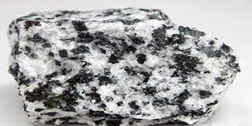 | Diorite | Dark colored plagioclase
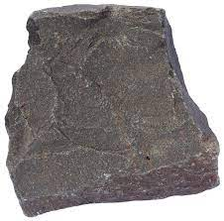 | Basalt | plagioclase feldspars
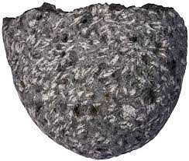 | Diabase | plagioclase feldspars and glass
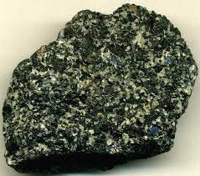 | Gabbro | glass ilmenite
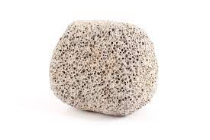 | Pumice | glass
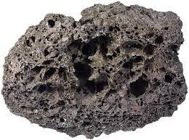 | Scoria | glass
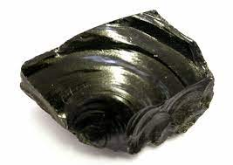 | Obsidian | black glass

Part 2:
Use this chart to identify the rocks in the photos that follow (55 pts)
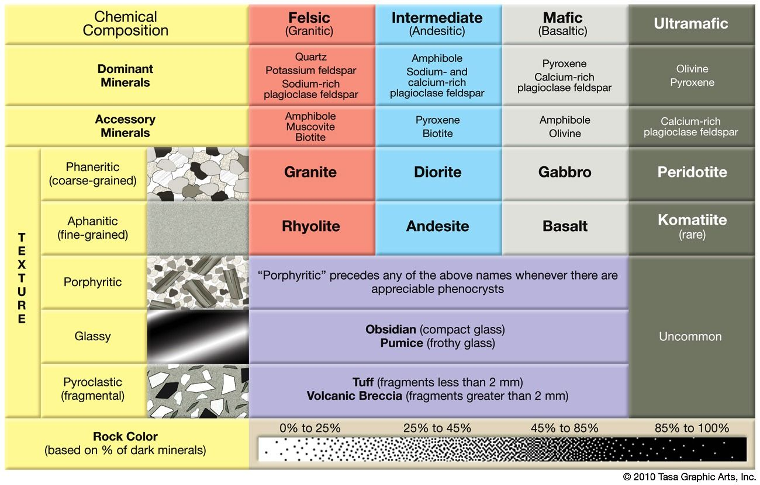

(next page)
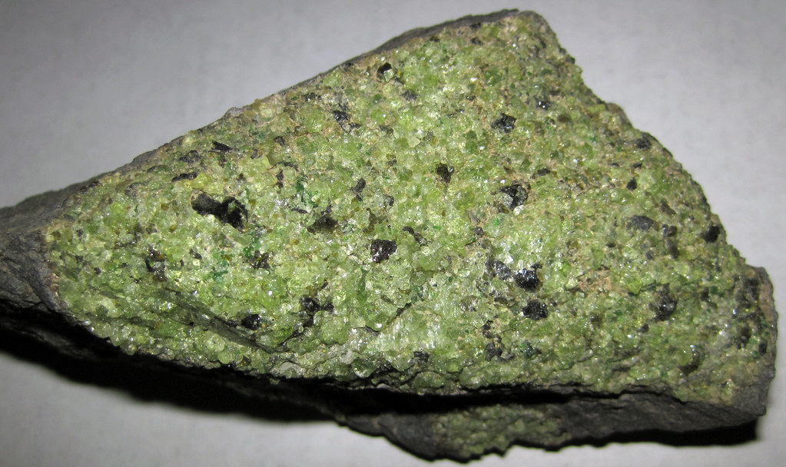

- Texture (circle one): phaneritic aphanitic porphyritic glassy pyroclastic texture

- (Circle one): Intrusive Extrusive

- Name (use the chart): komatiite

- Why did you choose this name (minerals present, texture, etc.)?

Fine grained
olivine

- (Circle one): felsic intermediate mafic ultramafic

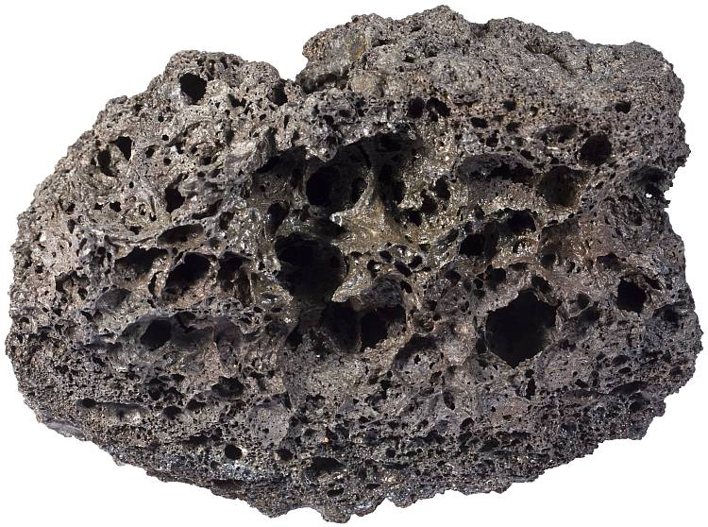
- Texture (circle one): phaneritic aphanitic porphyritic glassy pyroclastic texture

- (Circle one): Intrusive Extrusive

- Name (use the chart): volcanic breccia

- Why did you choose this name (minerals present, texture, etc.)?
Fragments greater than 2 mm

- (Circle one): felsic intermediate mafic ultramafic

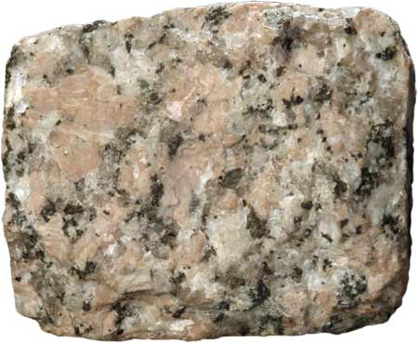

- Texture (circle one): phaneritic aphanitic porphyritic glassy pyroclastic texture

- (Circle one): Intrusive Extrusive

- Name (use the chart): granite

- Why did you choose this name (minerals present, texture, etc.)?

Course grained, light colored, quartz

- (Circle one): felsic intermediate mafic ultramafic

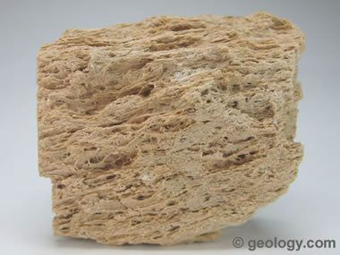

- Texture (circle one): phaneritic aphanitic porphyritic glassy pyroclastic texture

- (Circle one): Intrusive Extrusive

- Name (use the chart): pumice

- Why did you choose this name (minerals present, texture, etc.)?

light-colored vesicular

- (Circle one): felsic intermediate mafic ultramafic

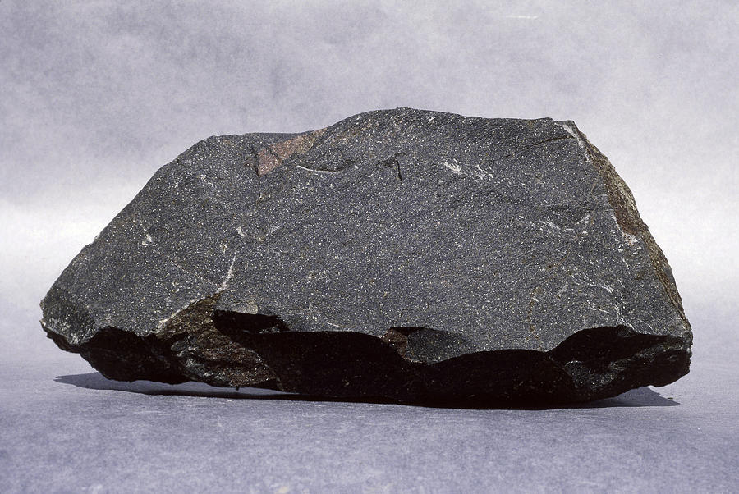

- Texture (circle one): phaneritic aphanitic porphyritic glassy pyroclastic texture

- (Circle one): Intrusive Extrusive

- Name (use the chart): basalt

- Why did you choose this name (minerals present, texture, etc.)?

Plagioclase,
Fine grained,
Dark color

- (Circle one): felsic intermediate mafic ultramafic

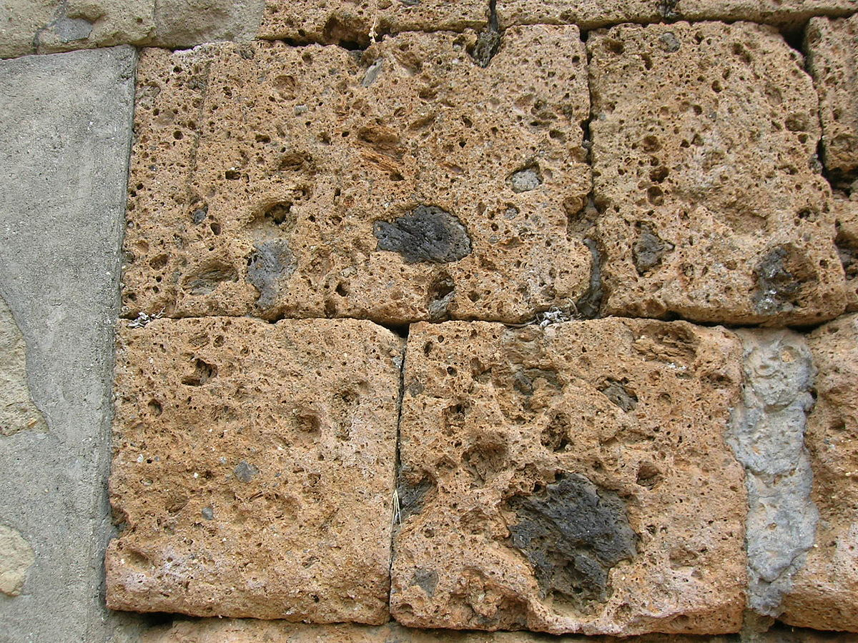

- Texture (circle one): phaneritic aphanitic porphyritic glassy pyroclastic texture

- (Circle one): Intrusive Extrusive

- Name (use the chart): andesite

- Why did you choose this name (minerals present, texture, etc.)?

Fine grained, plagioclase, pyroxene

- (Circle one): felsic intermediate mafic ultramafic

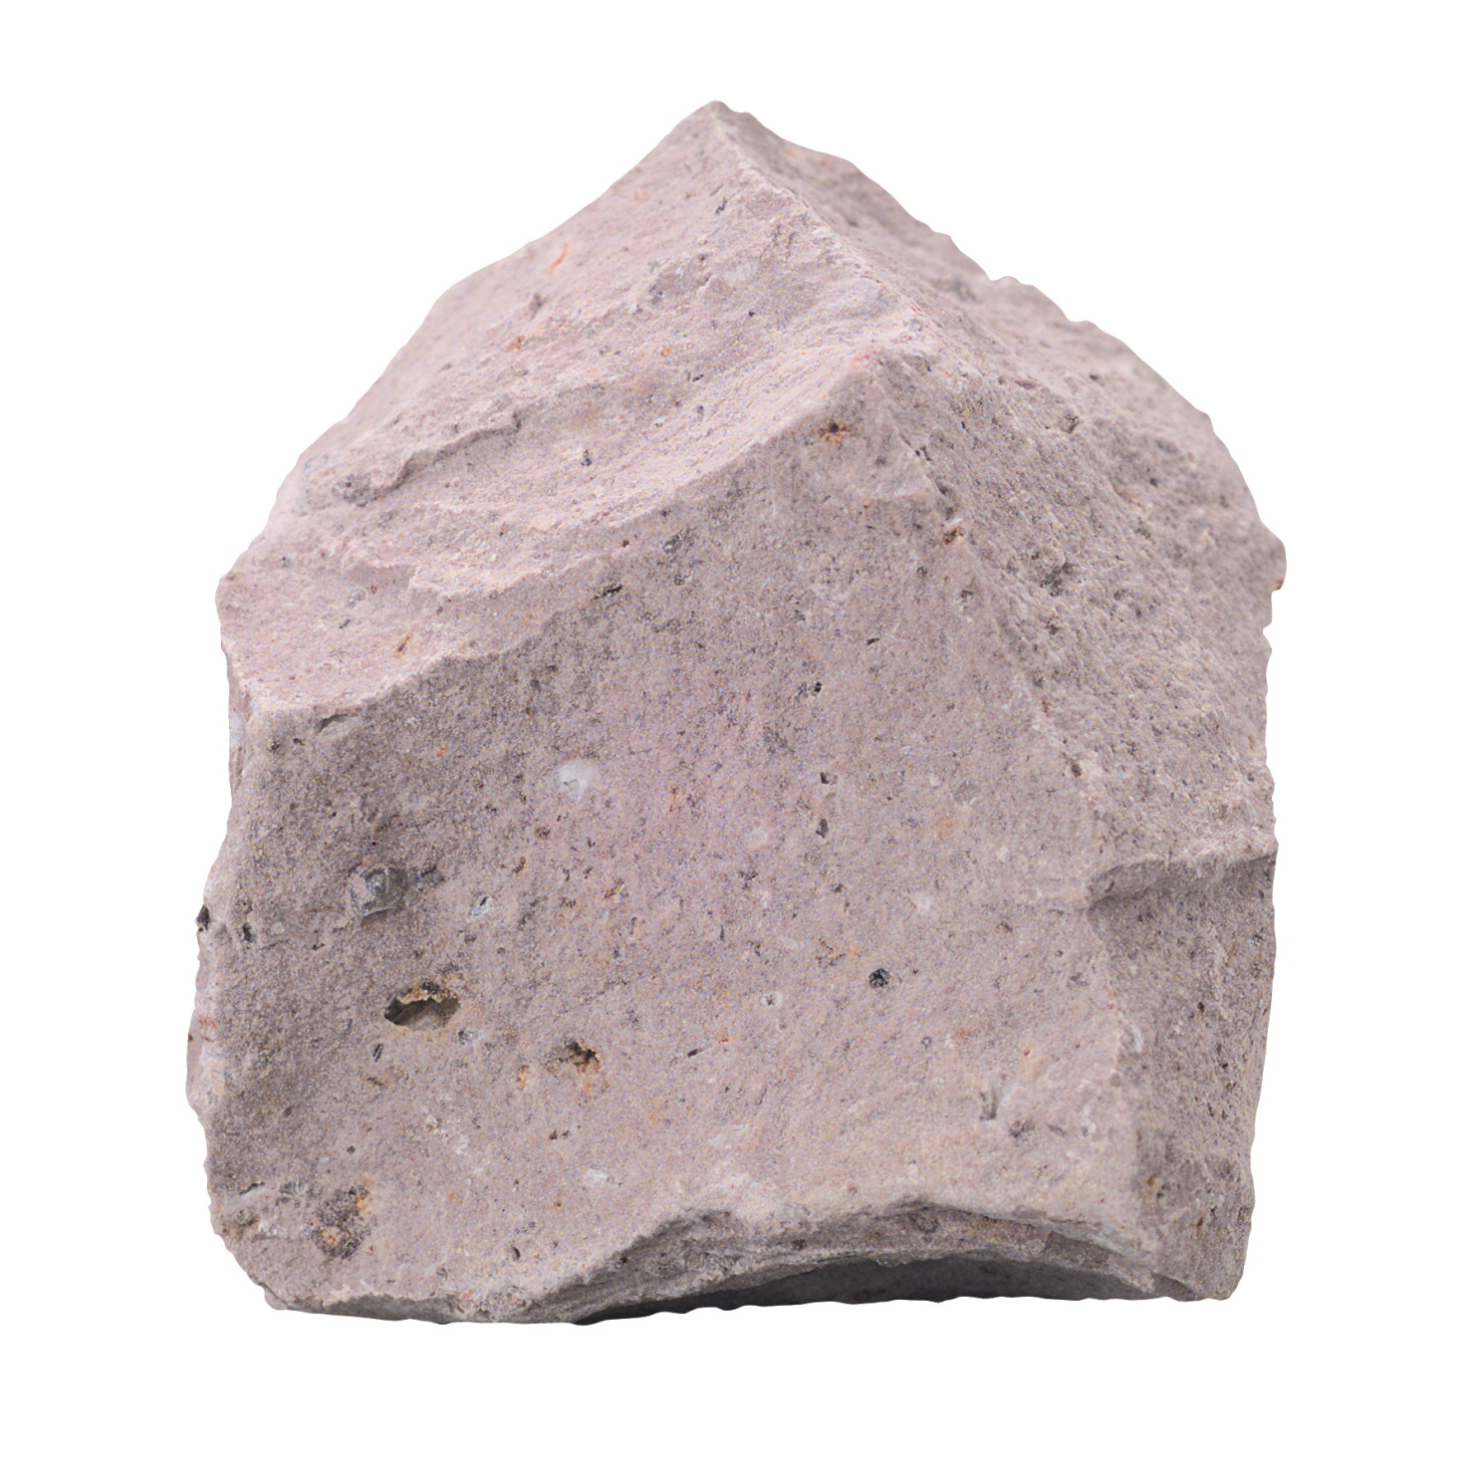
- Texture (circle one): phaneritic aphanitic porphyritic glassy pyroclastic texture

- (Circle one): Intrusive Extrusive

- Name (use the chart):

- Why did you choose this name (minerals present, texture, etc.)?

light-colored, fine-grained,
quartz and feldspar minerals

- (Circle one): felsic intermediate mafic ultramafic

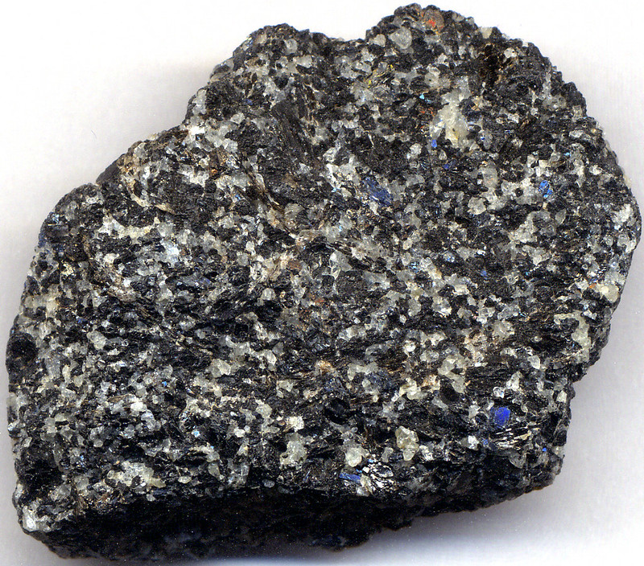

- Texture (circle one): phaneritic aphanitic porphyritic glassy pyroclastic texture

- (Circle one): Intrusive Extrusive

- Name (use the chart): peridotite

- Why did you choose this name (minerals present, texture, etc.)?

coarse-grained
olivine.

- (Circle one): felsic intermediate mafic ultramafic

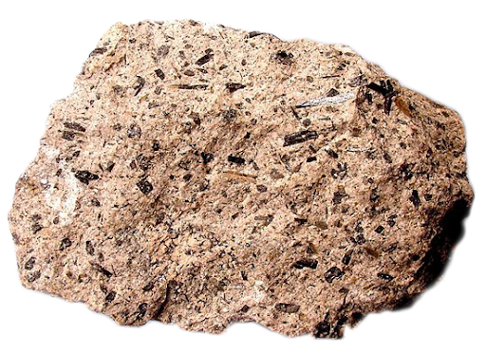

- Texture (circle one): phaneritic aphanitic porphyritic glassy pyroclastic texture

- (Circle one): Intrusive Extrusive

- Name (use the chart): tuff

- Why did you choose this name (minerals present, texture, etc.)?

Fragments less than 2 mm

cinders
Light to dark brown

- (Circle one): felsic intermediate mafic ultramafic

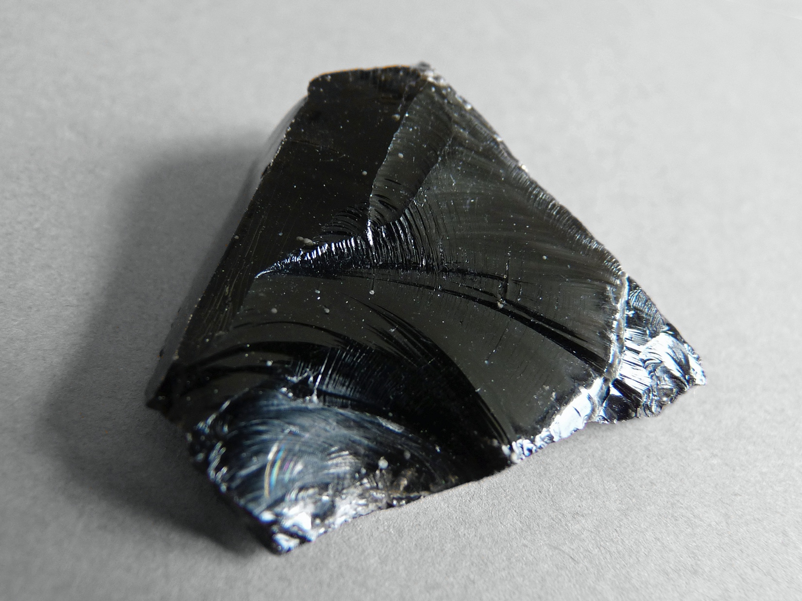

- Texture (circle one): phaneritic aphanitic porphyritic glassy pyroclastic texture

- (Circle one): Intrusive Extrusive

- Name (use the chart): obsidian

- Why did you choose this name (minerals present, texture, etc.)?

Compact glass, glassy in texture

- (Circle one): felsic intermediate mafic ultramafic

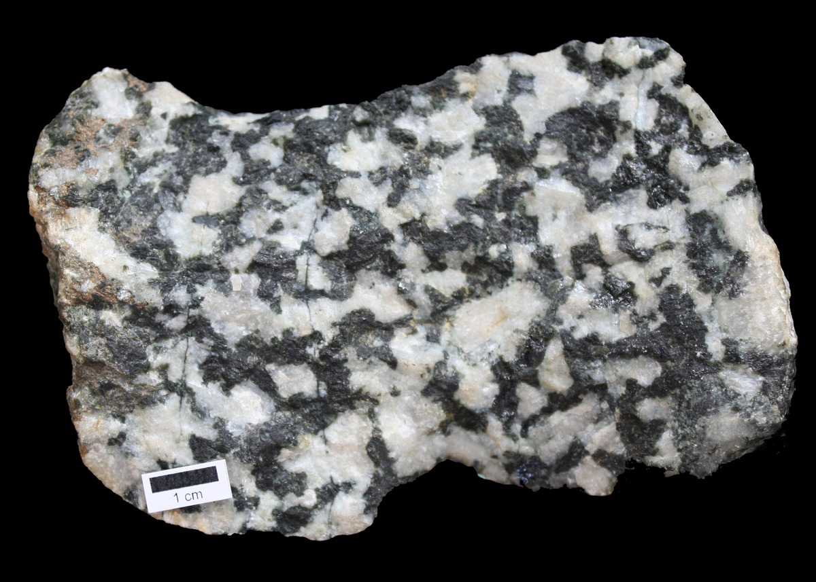

- Texture (circle one): phaneritic aphanitic porphyritic glassy pyroclastic texture

- (Circle one): Intrusive Extrusive

- Name (use the chart): diorite

- Why did you choose this name (minerals present, texture, etc.)?
plagioclase feldspar, Coarse grained,

- (Circle one): felsic intermediate mafic ultramafic

